**NAME:- Moinak Majumdar**

**REGISTRATION NO:- 1031911100367**

**ROLL:- 1191303 NO:- 61943**

**PAPER CODE :- CMSACOR03P**

Department of Computer Science

Barrackpore RastraguruSurendranath College

**-:INDEX:-**

|  |  |  |
| --- | --- | --- |
| SERIAL NO | CODE NAME | PAGE NO |
| 1 | Sum of any number of integers entered as command line arguments. | 1 |
| 2 | Take input from keyboard using following classes  i) DataInputStream ii) BufferedReader  iii) Scanner. | 2-3 |
| 3 | print all prime numbers within a given range | 4-5 |
| 4 | To take ten numbers as input and sort them is ascending order. | 6-7 |
| 5 | To take Account no, Name and Balance as input of ten customers and display the name and account no of those customers whose balance is less than one thousand. | 8-9 |
| 6 | Create a class named Figure Make Circle, square and triangle as object of the class Figure and calculate their surface area by concept of constructor overloading. | 10-11 |
| 7 | Create a class named Figure Make Circle, square and triangle as object of the class Figure and calculate their surface area by concept of method overloading. | 12-13 |
| 8 | Create a class Parent with one variable and one method. Create a class Child which inherits members from parent. Use the members of parent from child class and from third party environment | 14-15 |
| 9 | To check whether a given string is palindrome or not? | 16-17 |
| 10 | To create Interface. Implement this Interface in another Java Program. | 18 |
| 11 | To implement Multi-Threading concept | 19-20 |
| 12 | An Applet code to implement passing parameters in Applet using “PARAM” tag | 21 |

**Bibliography**

BOOKS:

1. “programming with java A Primer” by E.Balagurusamy

5th  edition, 2015 by McGraw Hill Education (india) Private Limited

Web sites :

1. Artificial Intelligence, Available at: [www.geeksforgeeks.org/](http://www.geeksforgeeks.org/)

Accessed on: 8-11-2020

1. Write a Java code to find the sum of any number of integers entered as command line arguments.

class cmd_line

{

public static void main(String[] args)

{

int a=Integer.parseInt(args[0]);

int b=Integer.parseInt(args[1]);

int c=a+b;

System.out.println("Addition of two no is:"+c);

}

}

Output :

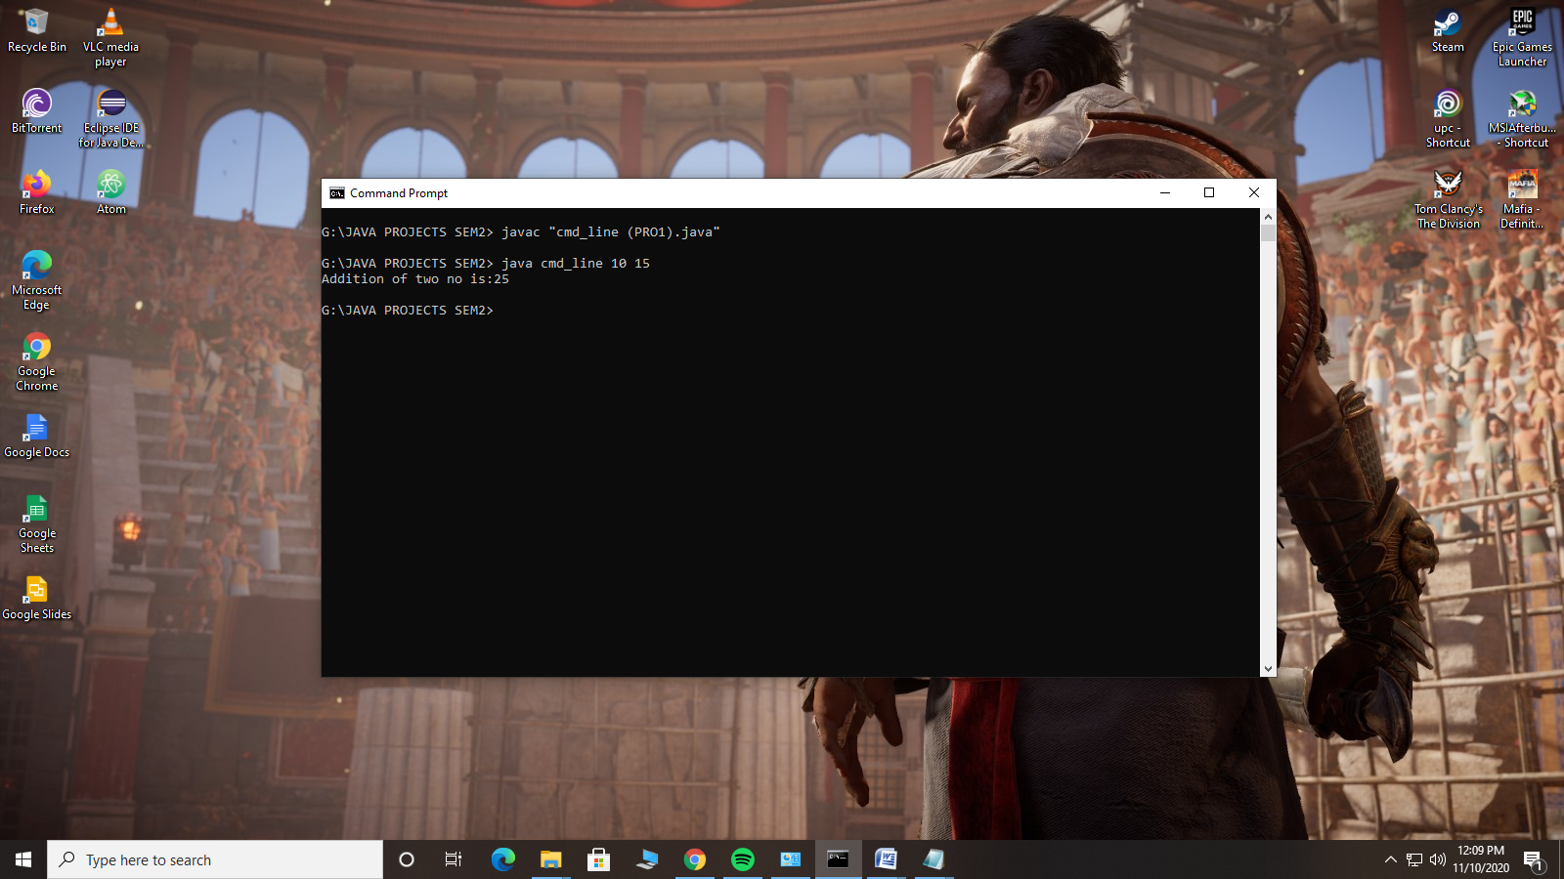

Page -1

2. Write a Java code to calculate factorial of a number. Take input from keyboard using following classes

i) DataInputStream

ii) BufferedReader

iii) Scanner.

import java.io.*;

import java.util.Scanner;

class factorial

{

int fact(int i)

{

int res=1;

for(int j=1;j<=i;j++)

{

res=res*j;

}

return res;

}

}

public class input_fact {

public static void main(String[] args) throws Exception

{

factorial f = new factorial();

System.out.println("//Taking input using SCANNER Class//");

System.out.println("Enter a positive no to calculate factorial==>");

Scanner sc =new Scanner(System.in);

int no1 = sc.nextInt(); page -2

System.out.println("Result is==>"+f.fact(no1));

System.out.println("//Taking input using Buffered_Reader//");

System.out.println("Enter a positive no to calculate factorial==>");

InputStreamReader is =new InputStreamReader(System.in);

BufferedReader inp = new BufferedReader (is);

int no2= Integer.parseInt(inp.readLine());

System.out.println("Result is==>"+f.fact(no2));

System.out.println("//Taking input using Data_Input_Stream //");

System.out.println("Enter a positive no to calculate factorial==>");

DataInputStream di = new DataInputStream(System.in);

int no3=Integer.parseInt(di.readLine());

System.out.println("Result is==>"+f.fact(no3));

}

}

Output :

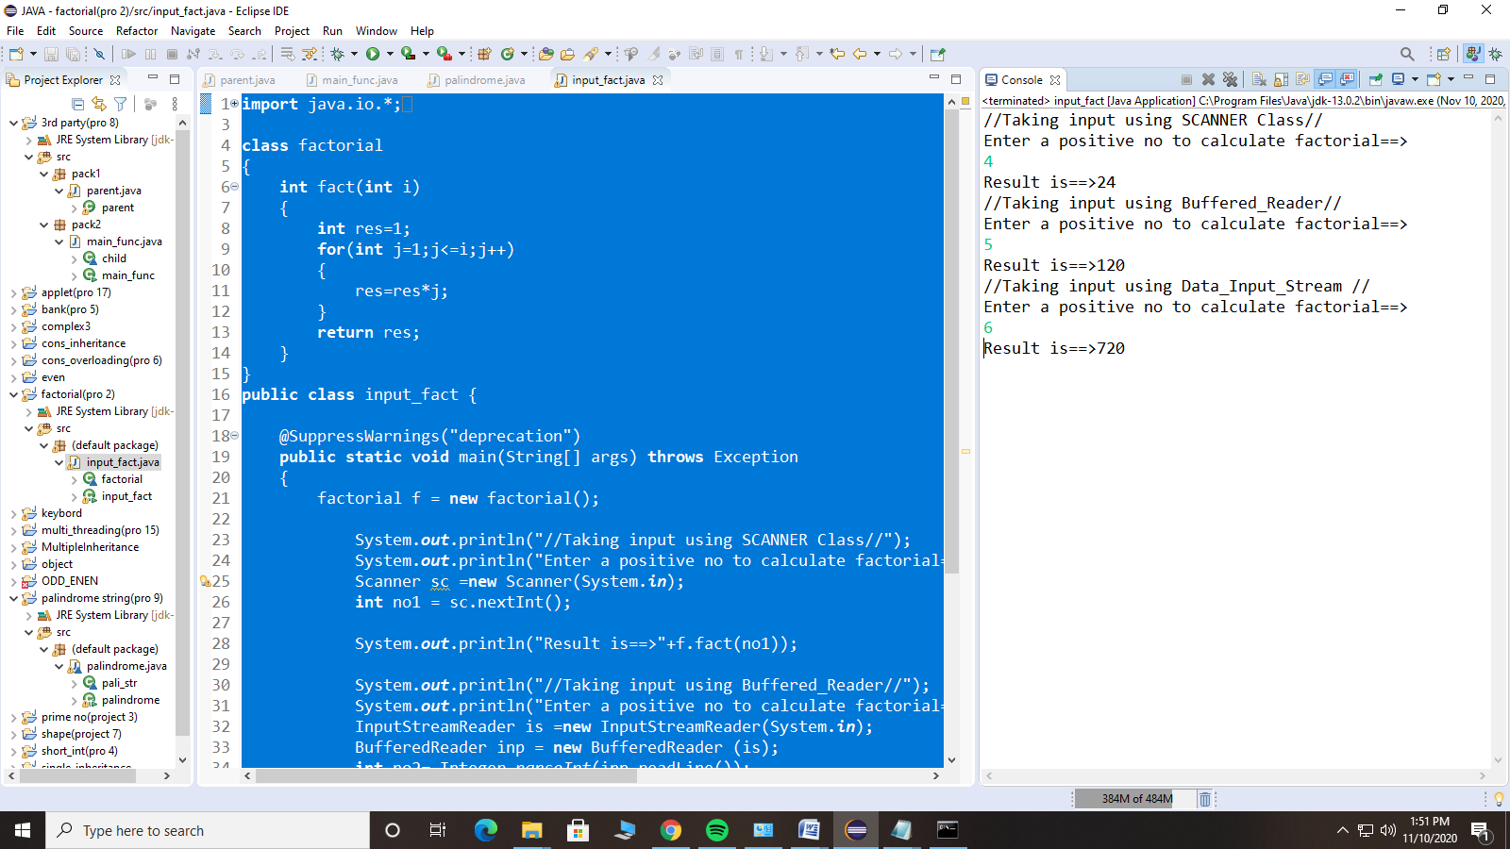

page -3

3. Write a java code to print all prime numbers within a given range

**import** java.util.Scanner;

**public** **class** prime_no {

**public** **static** **void** main(String args[])

{

Scanner sc = **new** Scanner(System.***in***);

**int** a, b, i, j, flag;

System.***out***.println("Enter lower bound of the interval==>");

a = sc.nextInt();

System.***out***.println("Enter upper bound of the interval==>");

b = sc.nextInt();

**if**(a>b)

System.***out***.printf("WARNING : lower bound must be smaller than upper bound!!");

**else**

{

System.***out***.printf("\nPrime numbers between %d and %d are: ", a, b);

**for** (i=a;i<=b;i++) // Traverse each number in the interval

{

**if** (i==1||i==0)

**continue**;

flag=1;

**for** (j=2;j<=i/2;++j)

{

**if** (i%j<= 0)

{

flag= 0;

**break**;

}

}

**if** (flag== 1)

System.***out***.printf("\n%d",i);

}

}

}

}

page -4

Output:

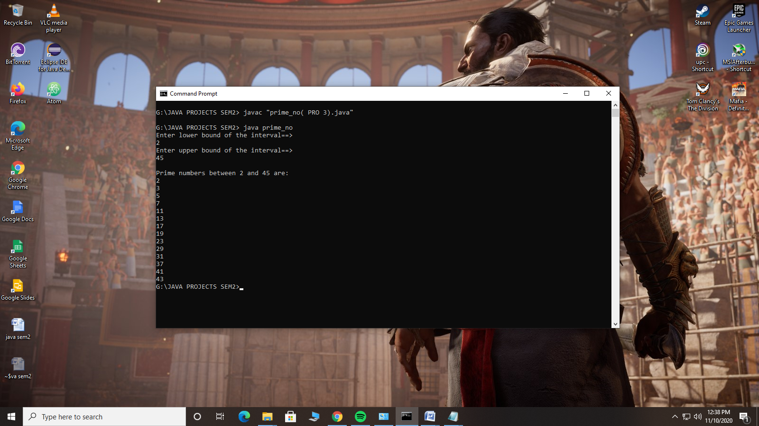

page -5

4. Write a Java code to take ten numbers as input and sort them is ascending order.

**import** java.util.Scanner;

**public** **class** ascending_sort {

**public** **static** **void** main(String args[]) {

**int** count=10, temp;

**int** num[] = **new** **int**[count];

Scanner scan = **new** Scanner(System.***in***);

System.***out***.println("Enter 10 array elements==>");

**for** (**int** i=0;i<count;i++)

{

num[i] = scan.nextInt();

}

**for** (**int** i = 0; i < count; i++)

{

**for** (**int** j = i+1;j<count;j++)

{

**if** (num[i] > num[j])

{

temp = num[i];

num[i] = num[j];

num[j] = temp;

}

}

}

System.***out***.println("Array Elements in Ascending Order==> ");

**for** (**int** i=0;i<count-1;i++)

{

System.***out***.print(num[i]+", ");

}

System.***out***.print(num[count-1]);

}

}

page -6

Output :

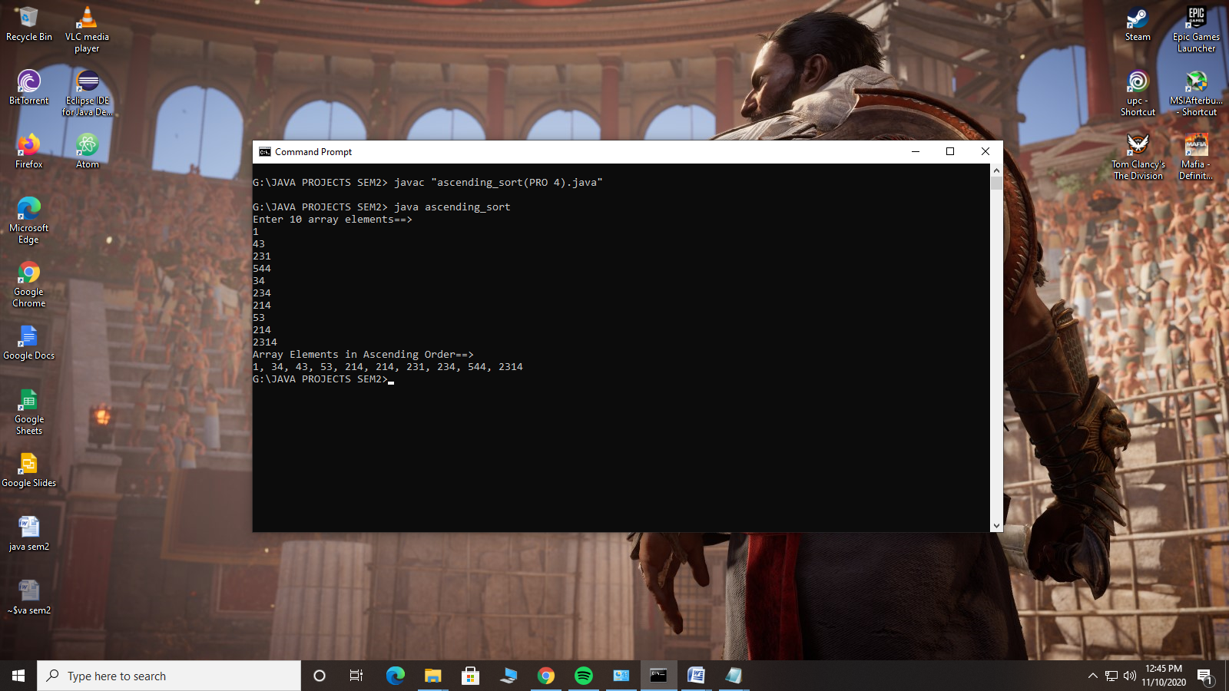

page -7

5. Write a java code to take Account no, Name and Balance as input of ten customers and display the name and account no of those customers whose balance is less than one thousand.

**import** java.util.Scanner;

**class** info

{

String name[] = **new** String[10];

**int** acc_no[]=**new** **int**[10];

**int** bal[]=**new** **int**[10];

**int** count=10;

**void** getData()

{

**for**(**int** i=1;i<=count;i++)

{

System.***out***.println("Enter details for use ("+i+")...");

System.***out***.println("Enter name==>");

Scanner scan = **new** Scanner(System.***in***);

name[i]=scan.nextLine();

System.***out***.println("Enter Account Number ==>");

acc_no[i]= scan.nextInt();

System.***out***.println("Enter Balance==>");

bal[i]=scan.nextInt();

}

}

**void** show()

{

**int** j=1;

System.***out***.println("Member with lass than 1000 balane are....");

**while**(j<=count)

{

**if**(bal[j]<1000)

{

System.***out***.println("Name -->"+name[j]);

System.***out***.println("Account Number-->"+acc_no[j]);

System.***out***.println("Balance -->"+bal[j]);

}

j++;

}

}

}

**public** **class** bank

{

**public** **static** **void** main(String[] args)

{

info obj= **new** info();

obj.getData();

obj.show();

}

} page -8

Output :

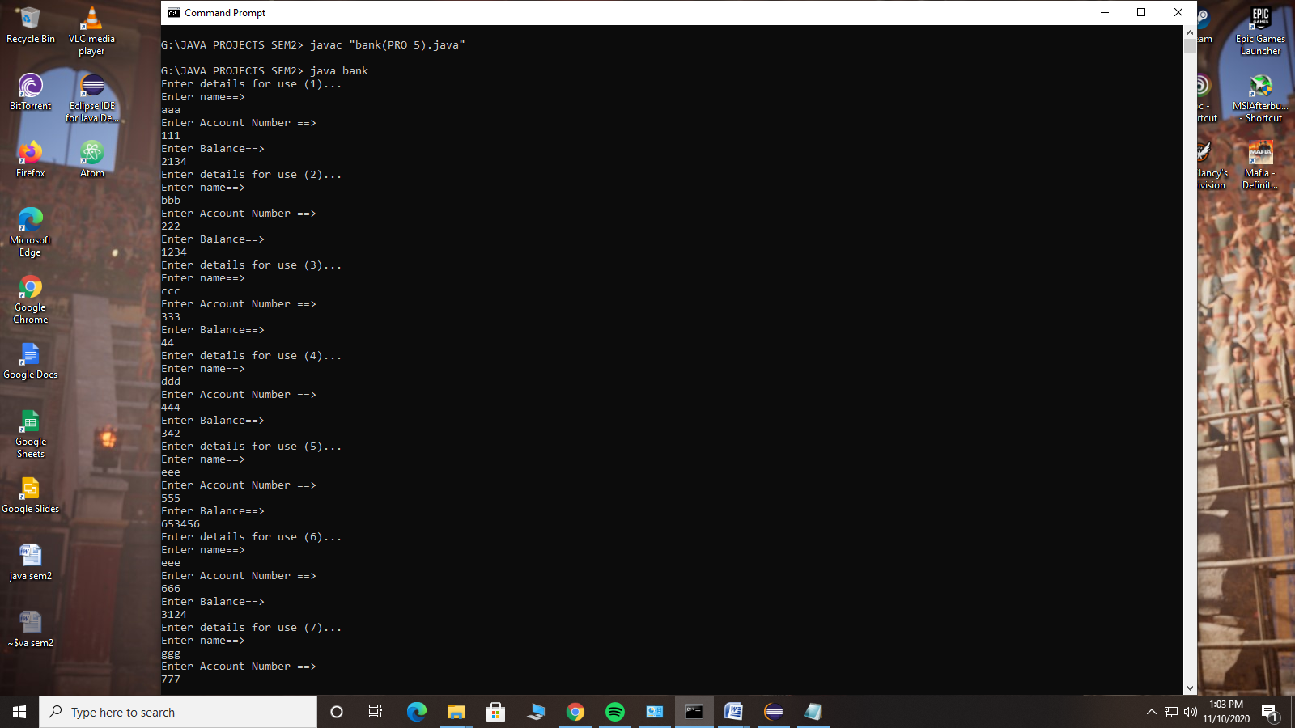  
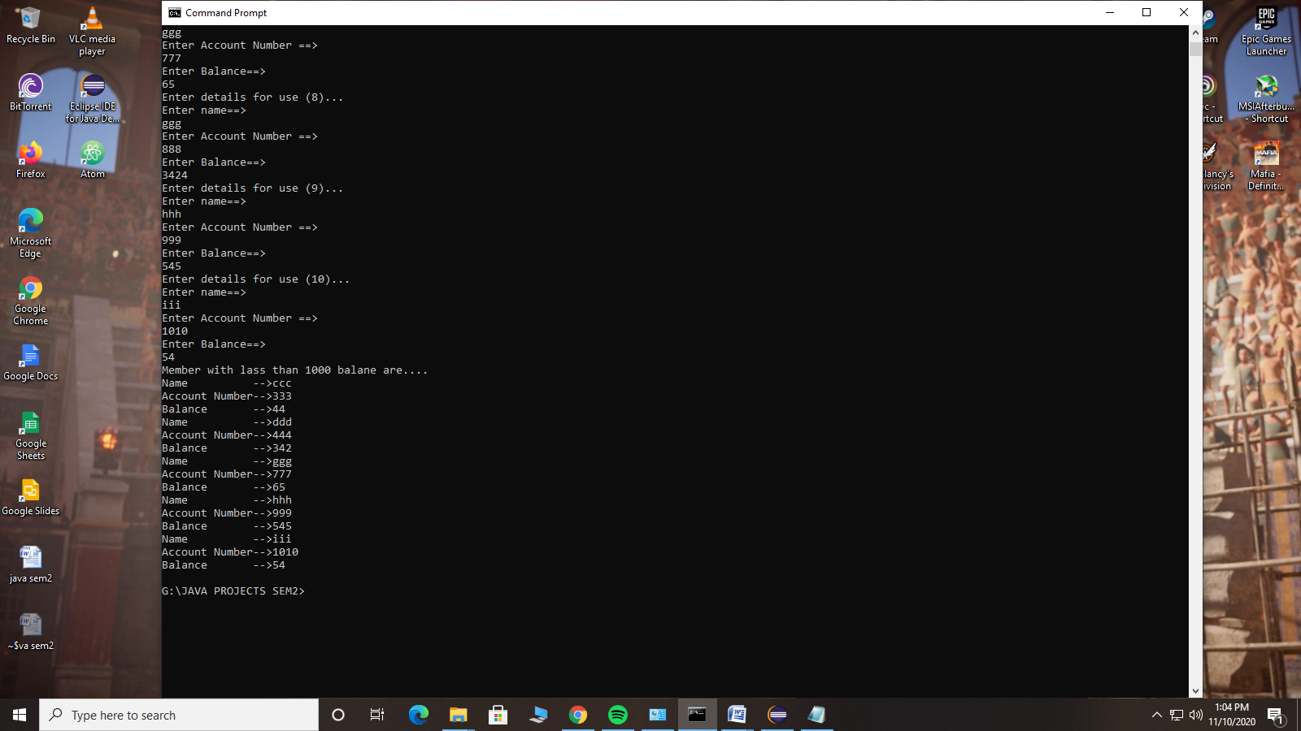

page -9

6. Create a class named Figure. Make Circle, square and triangle as object of the class Figure and calculate their surface area by concept of constructor overloading.

**class** surface

{

**float** r,a,b,x,y,z,res=1;

**private** **static** **float** *pi*=(**float**)3.141;

**public** surface(**float** i)

{ r=i; }

**public** surface(**float** i,**float** j)

{ a=i; b=j;}

**public** surface(**float** i,**float** j,**float** k)

{ x=i; y=j; z=k; }

**public** **void** cir_surface()

{

res=*pi*\*(r*r);

System.***out***.println("The surface area of a circle is==>"+res);

}

**public** **void** sq_surface()

{

res=a*b;

System.***out***.println("The surface area of a squar is==>"+res);

}

**public** **void** tr_surface()

{

**float** p=(x+y+z)/2;

**float** temp=(p*(p-x)*(p-y)*(p-z));

res=(**float**)Math.*sqrt*(temp);

System.***out***.println("The surface area of a triangle is==>"+res);

}

}

**class** Figure

{

**public** **static** **void** main(String[] args)

{

surface circle= **new** surface(7);

circle.cir_surface();

surface squar = **new** surface(4,4);

squar.sq_surface();

surface triangle= **new** surface(2,3,4);

triangle.tr_surface();

}

}

page -10

Output :

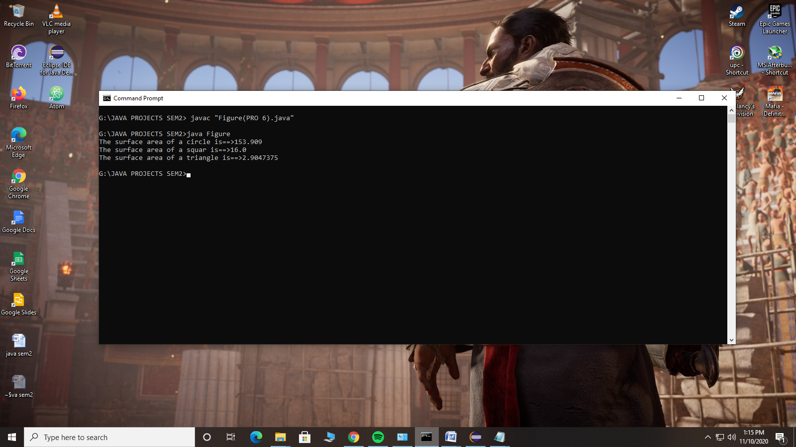

page -11

7. Create a class named Figure. Make Circle, square and triangle as object of the class Figure and calculate their surface area by concept of method overloading.

**import** java.lang.Math;

**class** area

{

**float** res,p,temp;

**private** **static** **float** *pi*=(**float**)3.141;

**float** area_cal(**int** i)

{

res=*pi*\*(i*i);

**return** res;

}

**float** area_cal(**int** i,**int** j)

{

res=i*j;

**return** res;

}

**float** area_cal(**int** i,**int** j,**int** k)

{

p=(i+j+k)/2;

temp=(p*(p-i)*(p-j)*(p-k));

res=(**float**)Math.*sqrt*(temp);

**return** res;

}

}

**class** Figure {

**public** **static** **void** main(String[] args)

{

area circle= **new** area();

area squar= **new** area();

area triangle= **new** area();

System.***out***.println("Area of CIRCLE(r=7)==>"+circle.area_cal(8));

System.***out***.println("Area of SQUAR(l=4)==>"+squar.area_cal(5,5));

System.***out***.println("Area of TRIANGLE(a=4,b=5,c=6)==>"+triangle.area_cal(4,5,6));

}

}

page -12

Output:

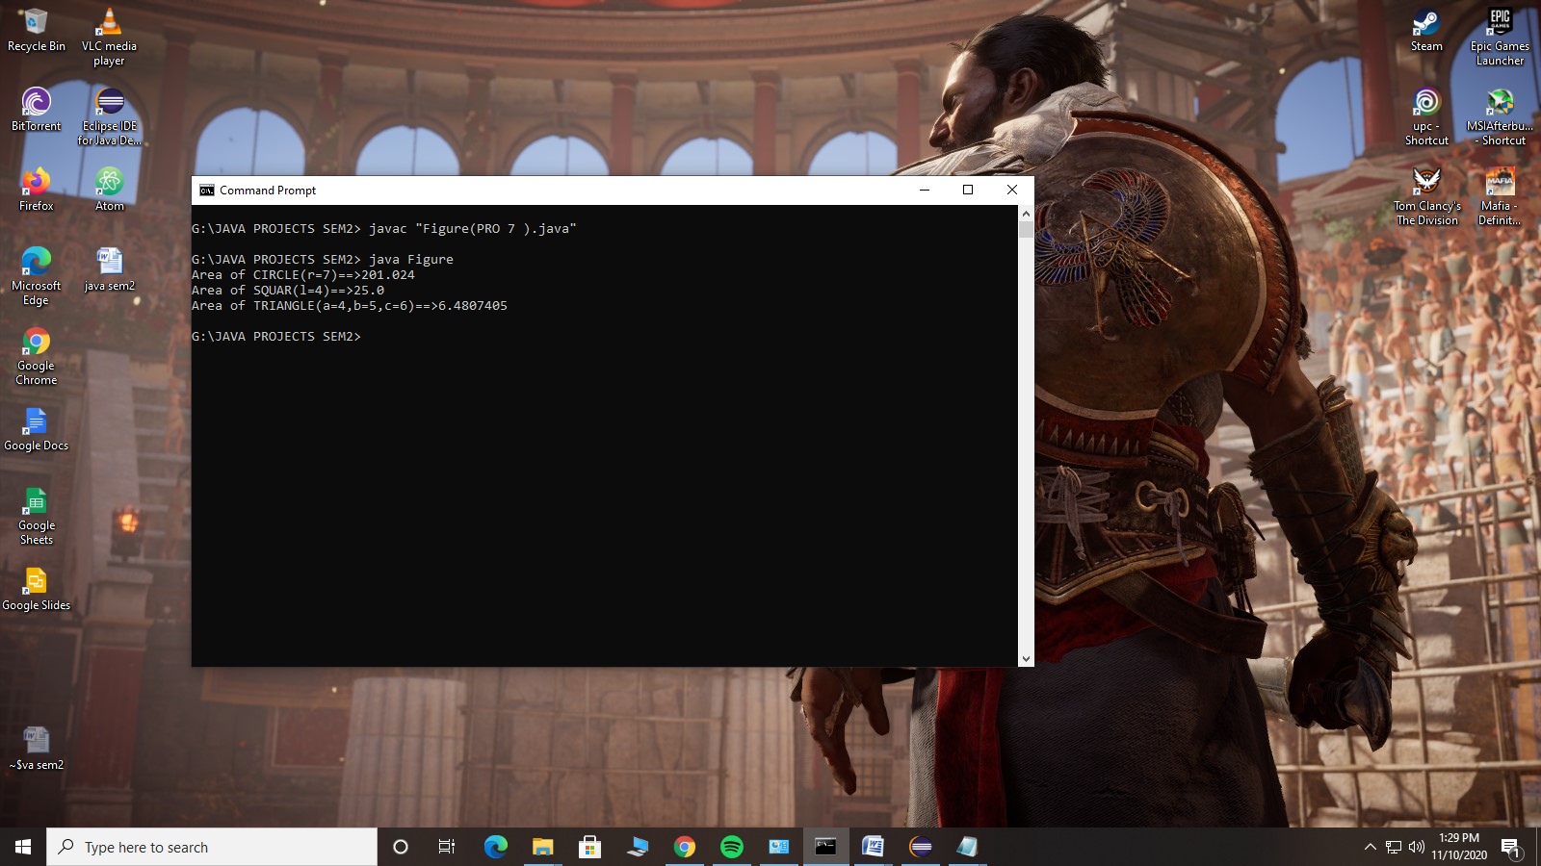

page -13

8. Create a class Parent with one variable and one method. Create a class Child which inherits members from parent. Use the members of parent from child class and from third party environment.

**package** pack1;

**import** java.util.Scanner;

**public** **class** parent

{

**public** **int** i;

**protected** **int** res;

**public** **void** add()

{

System.***out***.printf("\nWe are going to add a number with 5");

System.***out***.printf("\nEnter a number==>");

Scanner sc = **new** Scanner(System.***in***);

i=sc.nextInt();

res=i+5;

}

}

*At another package:-*

**package** pack2;

**import** pack1.*;

**class** child **extends** parent

{

**public** **int** show()

{

**return** res;

}

}

**public** **class** main_func

{

**public** **static** **void** main(String[] args)

{

child obj = **new** child();

obj.add();

System.***out***.printf("The result is = %d",obj.show());

}

}

page -14

Output :

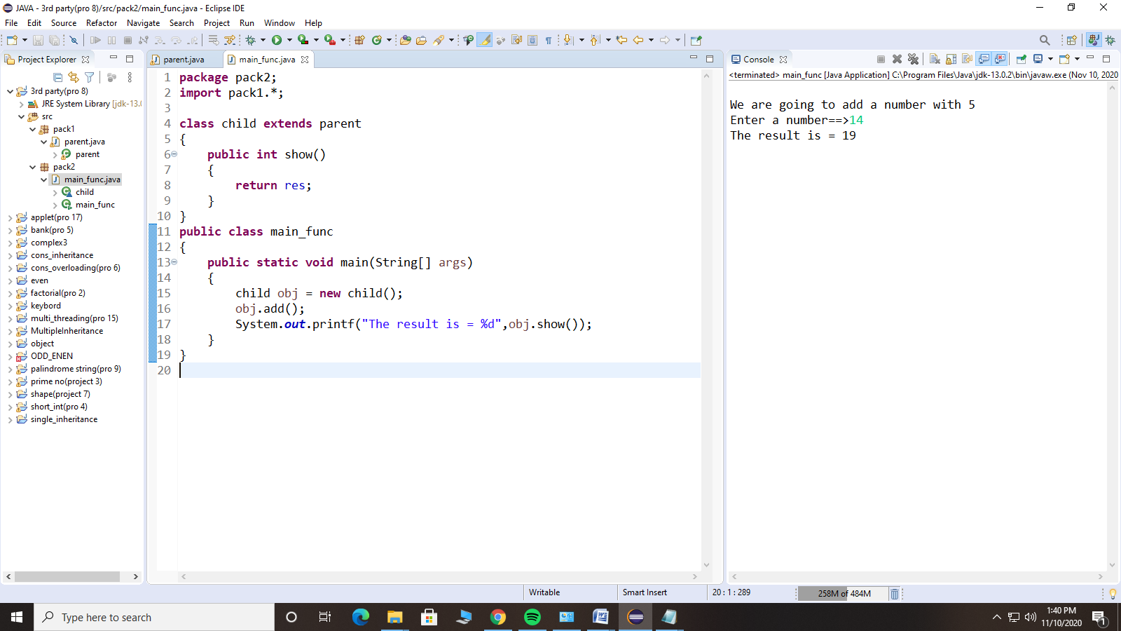

page -15

9. Write a java code to check whether a given string is palindrome or not?

**import** java.util.Scanner;

**class** pali_str {

**static** **boolean** isPalindrome(String str)

{

**int** i = 0, j = str.length() - 1;

**while** (i < j)

{

**if** (str.charAt(i) != str.charAt(j))

**return** **false**;

i++;

j--;

}

**return** **true**;

}

}

**class** palindrome {

**public** **static** **void** main(String[] args)

{

pali_str obj= **new** pali_str();

String str;

System.***out***.println("Enter a string==>");

Scanner sc = **new** Scanner(System.***in***);

str=sc.nextLine();

**if** (obj.*isPalindrome*(str))

System.***out***.print(str +" Is PALINDROME");

**else**

System.***out***.print(str +" Is NOT PALINDROME !!");

}

}

page -16

Output:

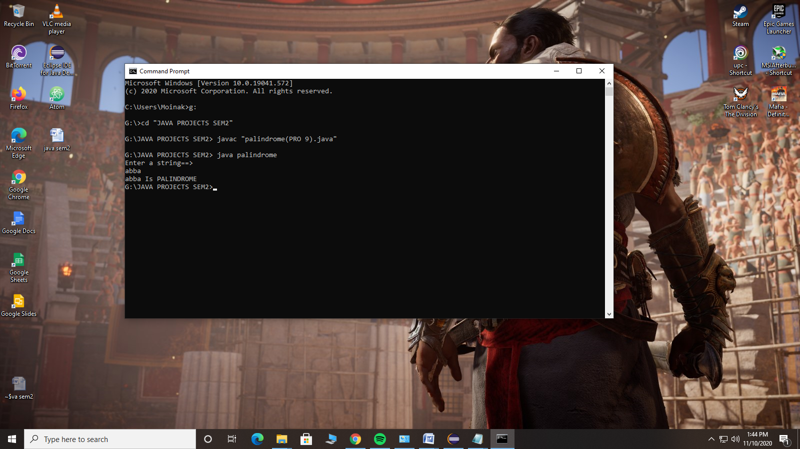

page -17

10. Write a Java code to create Interface. Implement this Interface in another Java Program.

**package** pack1;

**public** **interface** i1

{

**void** f1() ;

}

*At another package:-*

**package** pack2;

**import** pack1.*;

**class** A **implements** i1

{

**public** **void** f1()

{

**int** i=5;

System.***out***.println("the value is==>"+i);

}

}

**class** main_C

{

**public** **static** **void** main(String args[])

{

i1.*f1*();

}

}

Output:-

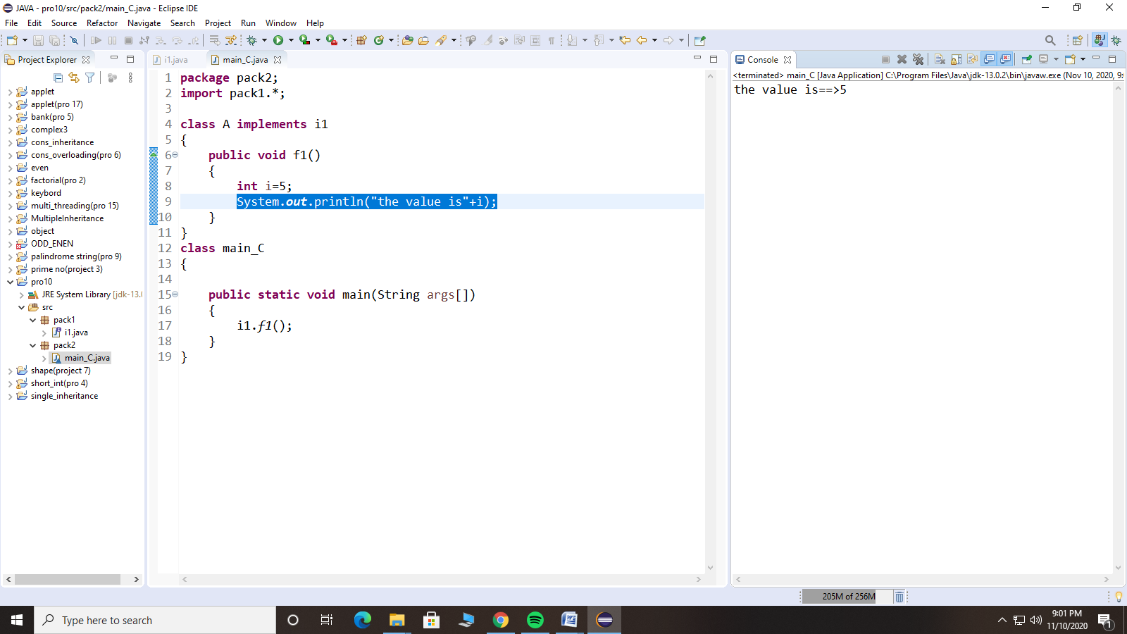

page -18

11. Write a Java code to implement Multi-Threading concept

**class** A **implements** Runnable

{

**public** **void** run()

{

**int** i;

**for**(i=0;i<=10;i++)

{

System.***out***.println("Thread A "+i);

}

}

}

**class** B **implements** Runnable

{

**public** **void** run()

{

**int** i;

**for**(i=0;i<=10;i++)

{

System.***out***.println("Thread B "+i);

}

}

}

**class** main_class

{

**public** **static** **void** main(String args[])

{

Thread t1= **new** Thread(**new** A());

Thread t2= **new** Thread(**new** B());

t1.start();

t2.start();

}

}

Output :

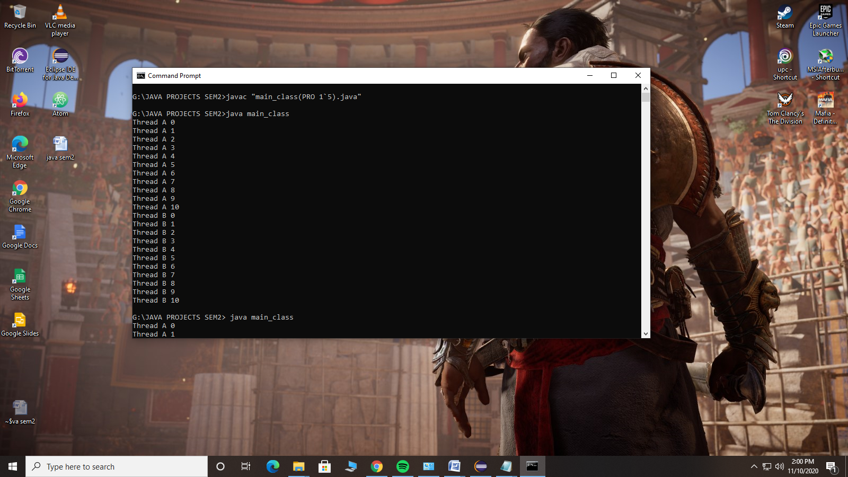

page -19

2nd Run:-

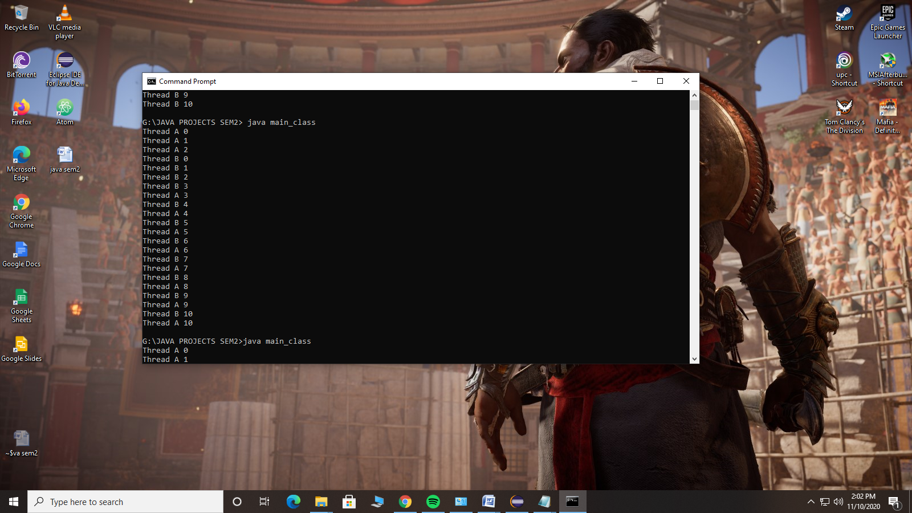

3rd Run :-

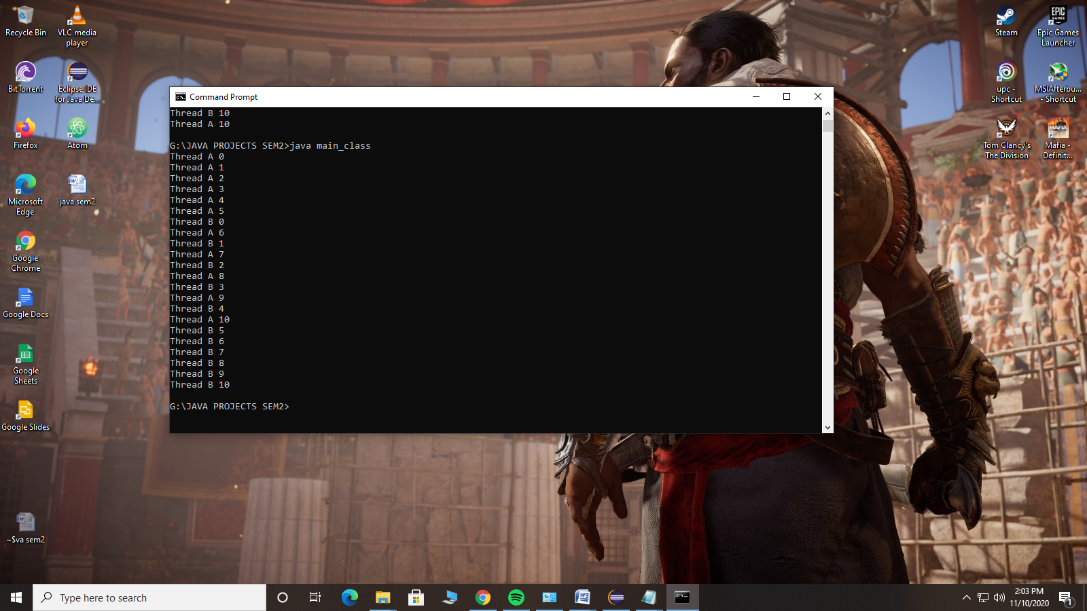

page -20

12. Write an Applet code to implement passing parameters in Applet using “PARAM” tag.

import java.applet.Applet;

import java.awt.*;

/*<applet code="MyApplet" width="400" height="220">

<param name="name" value="Moinak_Majumdar"/>

</applet> */

public class MyApplet extends Applet

{

String defaultMessage ="hello";

public void paint(Graphics g)

{

String s1=getParameter("name");

if(s1==null)

s1=defaultMessage;

g.drawString(s1, 50, 25);

}

}

Output:

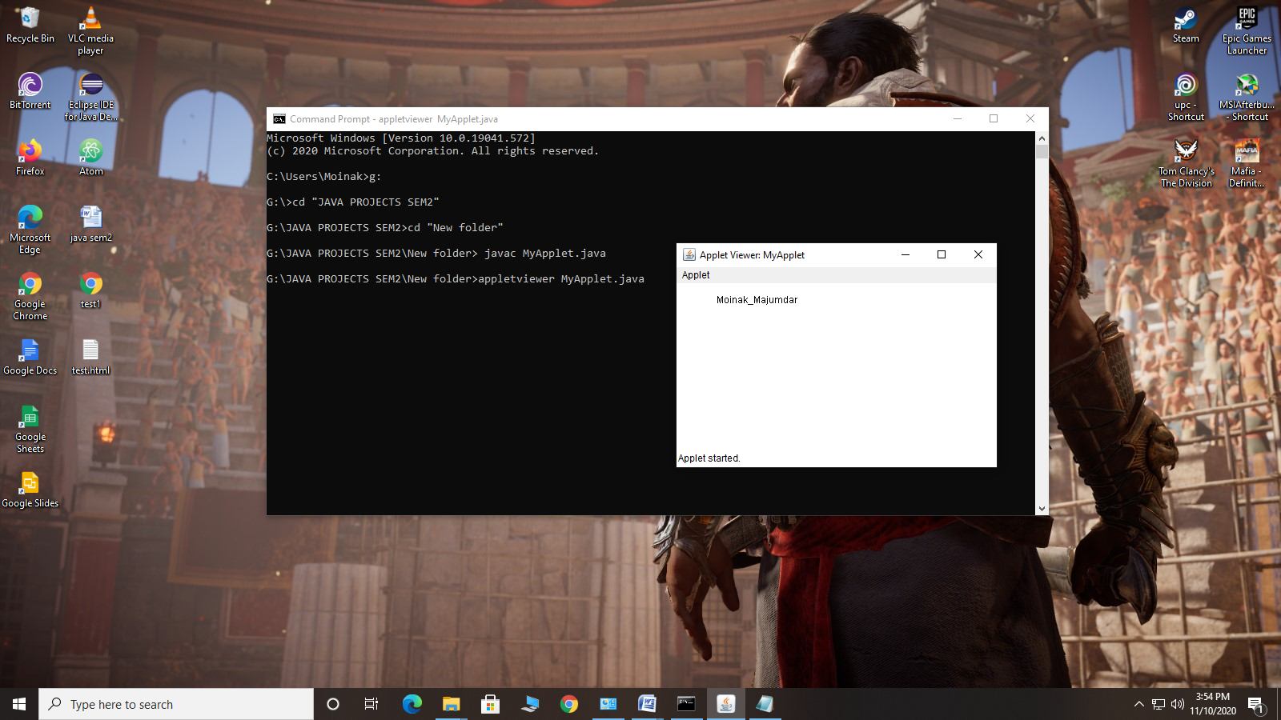 page -21